**Abstract submission requirements**

**General requirements:**

The abstract should be no more than one page.

Page format – A4 (21.0*29.7 cm).

Margins: left – 2.5 cm, right – 1.5 cm, top and bottom – 2 cm.

Font – Times New Roman (in formulas, the Symbol font is applied in addition to Times New Roman). For the main text, use 12 pt font size, the list of authors should be formatted to 14 pt. Line spacing – 1.

The text in the abstract should be aligned by width.

First line indent – 1.25 cm.

The title of the paper should be typed in capital letters; separated by a single line-spacing, indicated are the authors, the names of the organizations, cities, the authors' contact information; preceded by a double-line spacing, the text of the abstract is typed below.

**Requirements for figures and tables:**

All figures, tables and formulas should be referenced in the text. Decimal fractions in the table should have the same number of decimal places. Figures, tables and formulas are placed in the text. The figure caption should be typed under the figure in the center and indicate its number and title (12pt font, italic). The table caption should be typed above the table on the right and include its number and title (12pt font, italic). A minimum number of designations (numeric or alphabetic) is allowed in the figures. All explanations should be provided in the text under the figures. Figures, tables and formulas should be numbered in Arabic numerals. The formula number is typed on the right side of the sheet in parentheses. Superscripts and subscripts should be legible. Formulas and equations should be deciphered immediately below. References in the text should be indicated in square brackets. The list of references should be formatted in accordance with the requirements set forth in GOST 7.1-84.

Abstracts are accepted only in **doc, docx** format.

## Example of a report abstract:

**ACCOUNTING FOR UNCERTAINTIES IN geological transport MODELING problems solved to assess and demonstrate the SAFETY OF RADIOACTIVE WASTE DISPOSAL facilities**

###### A. Last Name1, B. Last Name2

*1Organization1*, *City1,*

*2Organization2, City2*

*e-mail:* [*name*@name.ru](mailto:name@name.ru)

Safety demonstration is considered as a key task at the design development and operational stage of any radioactive waste disposal facility providing for model assessments performed to evaluate the performance of the disposal system and accompanied by the uncertainty analysis [1]. Under a comprehensive safety assessment, the concentration of radionuclides can be used as an indicator along with the evaluated doses and risks. The concentrations are evaluated based on models of radionuclide transport in the geological environment. Uncertainties are inherent in the initial geological and operational data, the structural model of the geological environment, flow and transport parameterization data. Therefore, uncertainty analysis should be integral to the process along the entire calculation flowchart (Fig. 1)...

 (1)

The Monte Carlo method accounts for the simplest approach to calibration, uncertainty and sensitivity assessment: the configurations of input parameters are played out pseudo-randomly and a computational code is run for each set of parameters from the obtained sample [2]. In case if due to its resource intensity this approach turns out to be inapplicable, the Bayesian approach can be used alternatively: available observations are used to draw conclusions about the uncertainty of hidden parameters [3].

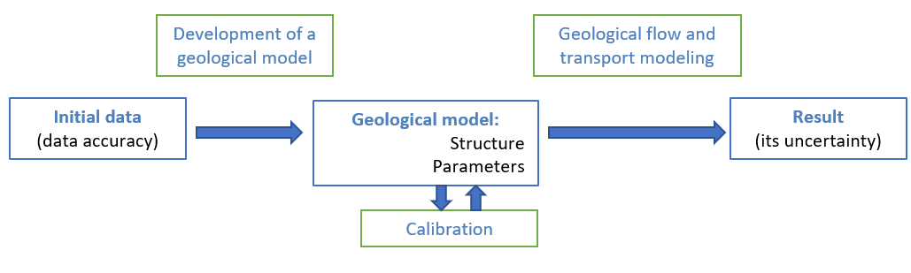

*Fig. 1. The flowchart followed to obtain the geological transport modelling result based on the initial data*

**References**

1. Disposal of Radioactive Waste. IAEA Safety Standards Series No. SSR-5, IAEA, Vienna, 2011 – 104 p.
2. Helton J. C. Uncertainty and sensitivity analysis techniques for use in performance assessment for radioactive waste disposal //Reliability Engineering & System Safety. – 1993. – 42(2) – p. 327-367.
3. Link W.A., Barker R.J., Bayesian Inference with Ecological Applications, Elsevier, 2010.